LINUX BASIC COMMANDS
PART-2

1) cp : used to copy files and directories in linux.

cp options source destination

cp file.txt file2.txt : content of file1 will be copied to file2.if file2 is not created then it will create that file.
Cp file1.txt dir1 : copy the file1 into directory dir1
cp file1.txt file2.txt dir2: copy the file1 and file2 in dir2
cp -i file1.txt file2.txt dir1: -i means interactive, it will for overwrite otherwise if we don’t use -i flag it won’t ask for overwrite and do it by default.
cp -R dir1 dir3 : -R is for recursive copying
if dir3 does’nt exist, it will copy the content of of dir1 into dir3
if dir3 exists, then it will copy dir1 into dir3.
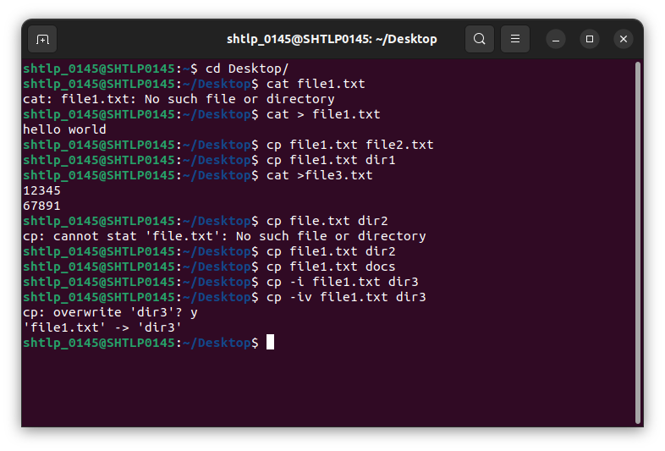
2)mv: used for renaming a file or directory and moving file or directory to another location.

mv options source destination

mv file1 file2: renaming file1 to file2

mv source destination_path:moving source to destination path.
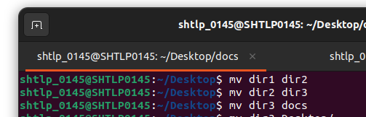

3) less:used to read the contents of a text file one page at a time.

Less filename

note: to end the process press “Q”

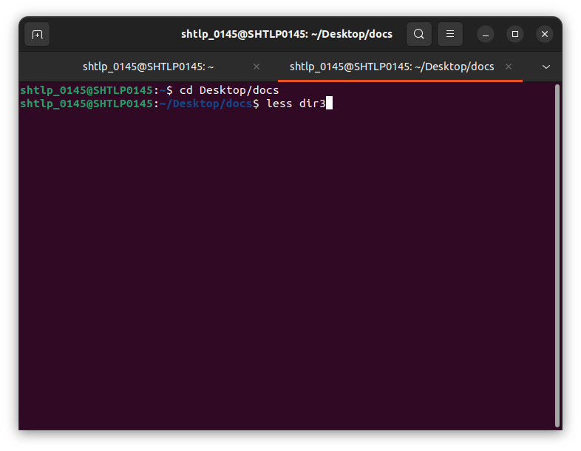

4) touch:used to create,change and modify timestamps of a file.

Note: difference between touch and cat
cat is used to create the file with content whilw touch is used to create a file without content.

touch file1
touch -a file1 : changes the access time of file1.
Touch -c file1: used to check whether a file is created or not.if not created then don’t create it.
Touch -c -d file1: used to update access and modification time.
Touch -m file1: used to change the modification time only.
Touch -d “17 mar 2023” file1.txt: used to change only modification date.
Touch -r file2 file1: used to use the timestamp of another file.

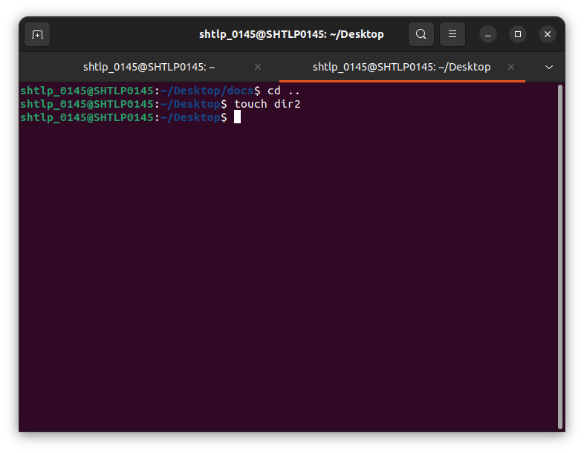

5) Nano: text editor having special features like goto line,col no. Etc

6) sudo: super user do.allows some extra priveledges as administrators.

7) top: to see which process is taking more memory or cpu

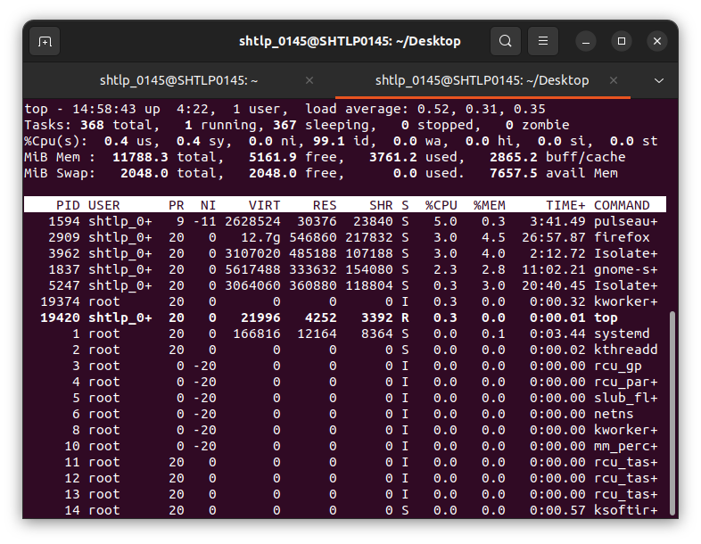
8) kill: to kill a process

kill -flags pid

to find pid of the process: pidof process_name

kill pid
kill -KILL pid: powerful command than simple kill command
kill -9 pid: powerful command than simple kill command

to find list of all running processes: ps ux
to find list of all running processes by all the users: ps aux
to find list of all running processes by a particular user: ps -U user_name
to find all the processes related to a program: ps -C process_name

9) echo : displays whatever we write after echo

echo hello world

myvar=”Mark”
echo $myvar

x=10
echo “the value of x is $x”
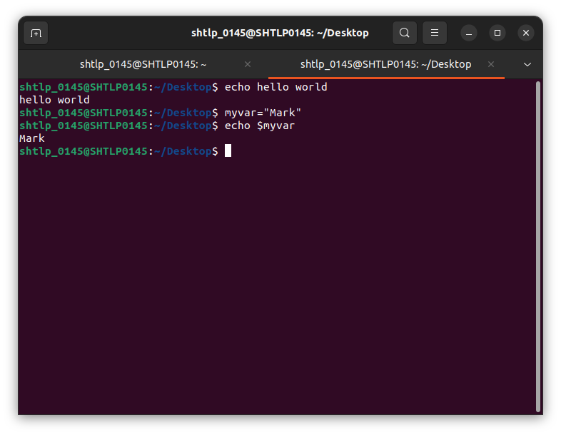
10)chmod: change the permission of file and directories

chmod o+x file
chmod o+w file
chmod g+x file
chmod g-wx file
chmod ug=rwx file
chmod ugo -rwx file
chmod u+rw,g=rw,o+r file

chmod u-w dir
chmod u+w dir

